Problem Identification
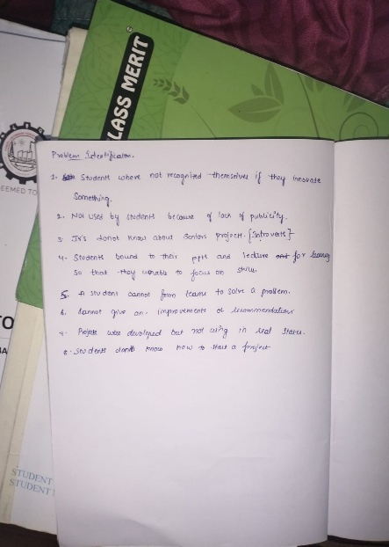
- No Recognition: Students are not recognized when they create or innovate something new.
- Lack of Publicity: Many student projects are not known because they are not properly promoted.
- Juniors Don’t Know Seniors’ Work: Junior students do not know about the projects done by seniors, so they miss learning from them.
- Less Practical Learning: Students focus more on lectures and PPTs and do not build real-world, hands-on projects.
- Hard to Find a Team: Even if a student wants to do a project, it is difficult to find the right team members.
- Projects Are Not Used: After completing a project, students usually just post it on LinkedIn and do not try to make it useful in real life.
- No Proper Guidance: Students do not get enough feedback or suggestions to improve their projects.
- Wrong Start: Many students stop working on projects halfway because they start without proper planning.
- No comments- user’s who are facing issues while using their applications and want to give suggestions to developer can’t communicate with them.

Required Tables:
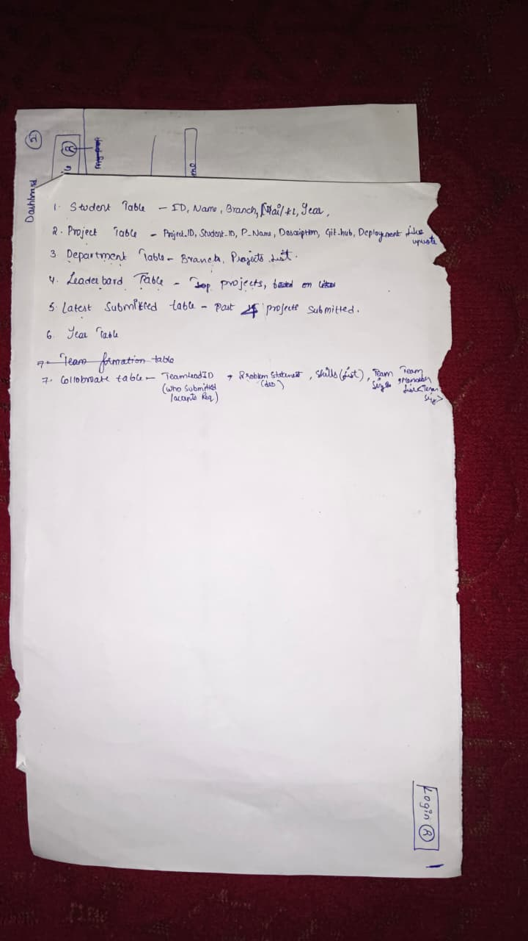
Student -Id (pk) , name, department(Fk), year, mail, List<projects>
Single Projects – project-Id(pk), Student-Id(fk), P-name, description, GitHub, documentation
Like(fk), upvote(fk)
Group Projects- project-Id(pk), list<Student-Id(fk)>, P-name, description, GitHub,
Documentation, Like(fk), upvote(fk)
Department- branch(pk), list<projects>, list<students>
Collaboration table – student-id(pk), size, description, skills, list<student_id(fk)>

Features
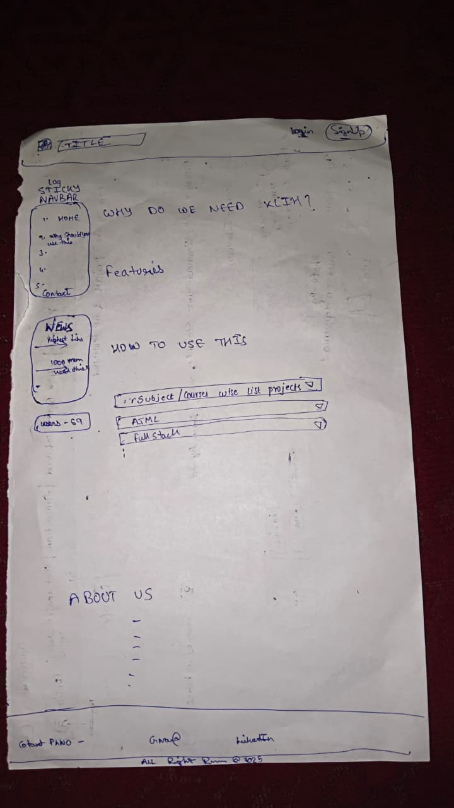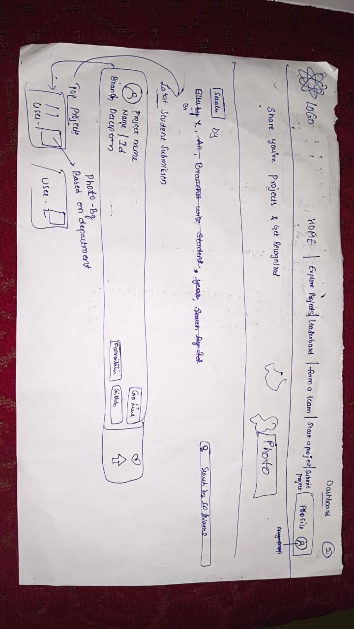

1.student login – enter email -> retrive idNO
->retrive branch
->year
-enter name
-enter opt
-enter captcha -login
2.LeaderBoard – display top 10 projects based on likes and upvotes
3.Form a team – define a problem statement
-mention required skills
-give team size
-approve/reject invitation
4.Submit project – enter description
- enter Project Name
- Give github link
- upload documentation

5.Latest Submittions – fetch projects by
date, time
6.Explore Projects – fetch by –
- 1year -select year and retrive all the projects of that year
- branch – show all the projects department wise
- Id – retrive project of that id no
- All-show all the projects
7.dashboard - display –
->student object
->Projects they have done,
->review comments on their live projects
- 3 technologies used in it
Service Class

Student String CreateStudentByEmail(String email);
Student getStudentById();
Student getStudentByEmail();

Project String SubmitProject(Project p);
List<Project> getLatestSubmissions();
List<Project> getAllProjects();
List<Project> getProjectsByYear();
List<Project> getProjectsByBranch();
List<Project> getProjectsByid(int id);

GroupProject String SubmitGroupProject(GroupProject p);
List<GroupProject> getLatestGroupSubmissions();
List<GroupProject> getAllProjects();
List<GroupProject> getProjectsByYear();
List<GroupProject> getProjectsByBranch();
List<GroupProject> getProjectsByid(int id);

Collaboration String CreateTeam(Collaboration collab);

ProjectLikes List<Project> getTopProjects();
List<GroupProject> getTopGroupProjects();

